**Camera**

When rendering the game to the screen we will be using Unreal built in camera. With this we will mix in both a player controlled third person camera and a on rail camera transitions for when the player is within curtain areas.

**Anchors:**

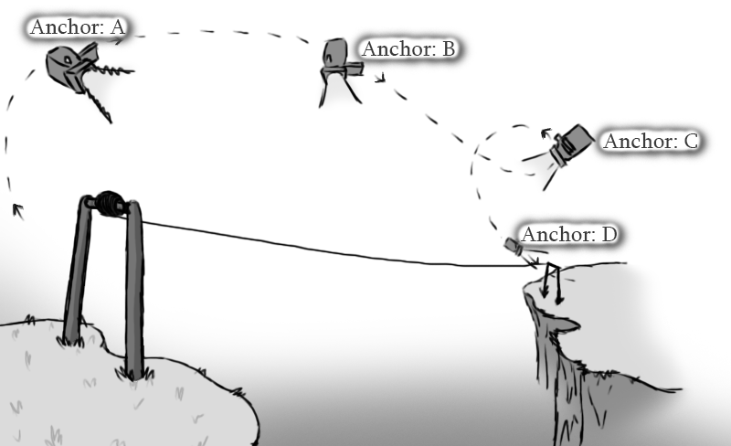

Figure - 4* Camera Anchors attached to Zip Line Segment

The team has decided that rather the controlling the game camera’s transform directly through scripts, by adding or subtracting vectors to its position, a better approach would be the use of camera Anchors. In scripted sections like ziplines the camera will use linear interpolation to move from one a given point to another. These points will be labelled as camera anchors and will consist of an empty “actor” with only an attached transform.

**Linear Interpolation:**

When moving a transform between two points we will be using linear interpolation, as stated above.

**Lerp (start, end, alpha);**

This is the linear interpolation (Lerp) function built into UE4, the start and end are the transform components of each anchor we want the camera to lerp between, the alpha is how far in between these two positions the camera is going to be at. This is from 0 to 1.

**New Transform = start * (1 - alpha) + finish * alpha;**